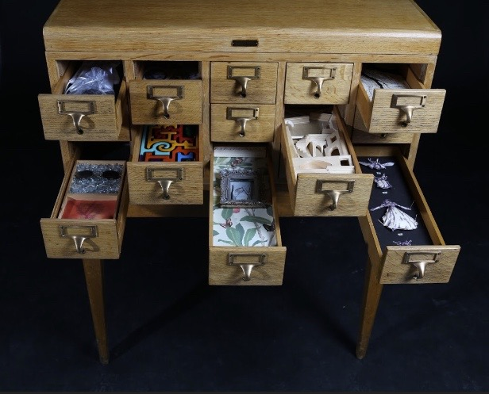

This is a call for artists and writers working across a wide spectrum of media to participate in the fall exhibit of **The Boxed Stories Gallery** located in the **Creative Hive space of Loft 112, 535 8 Ave SE Calgary**

**A bit about the Gallery**: Housed within a vintage card catalogue, the library’s one time answer to organizing a collection of books for readers to locate on a shelf, visitors will be encouraged to discover varied artworks as they open each drawer.

The pieces can range from paintings, prints, photography, assemblage, music as well as wood, metal and ceramic sculpture and/or any other format the artist/writer imagines.

The dimensions of each must fit and fill the drawer: Length- 15.25” Width - 5” Height 2” . Once chosen, artists/writers will be able to come and explore their drawer for planning purposes.

**Timeline**

**June 30, 2020** **Letter of interest** (1 page) stating your interest/availability/concept if you have one; background experience, education, projects and/or anything else you wish to share with us. In the event we receive more interest then spots, this will help us choose participants.

**September 7-11, 2020 Install:** Details forthcoming once we better understand our opening date (projected September 6, 2020) and surrounding protocol

**September 24, 2020 Opening Night:** TBD again depending on state of covid recommendations

**December 16, 2020 Takedown:** unless otherwise changed due to covid

**Payment**

-Loft 112 will pay each participant of The Boxed Stories Gallery $100 for a total of $3,000 (30 artists x$100 each)

-Loft will host the opening reception and pay for any of the associated print and advertising materials

-Each artist/writer can decide if the piece will be available for sale (or prints made available for sale) and price accordingly. 100% of the sale goes back to the creator.

-The art/text will remain as part of the gallery until the final date of the exhibition.

Please direct all inquiries to Stacey Walyuchow: [loft112bookings@gmail.com](mailto:loft112bookings@gmail.com)

Please direct Letter of Interest to Lisa Murphy Lamb: [loftonetwelve@gmail.com](mailto:loftonetwelve@gmail.com)

Please share with your various communities. We want to box your stories.

**Call for artists and writers from all practices and from all of Calgary’s communities to participate in the**

**The Boxed Stories Gallery**

**Fall Exhibit**

**September - December 2020**

**Opening Night**

**September 24, 2020\***

Image from the Infinite archive New York Public Library